Name: Zackery Hatch Date: 2/8/21 Per: 2

Quantum Numbers Worksheet

___1__1. How many sublevels are in energy level 1?

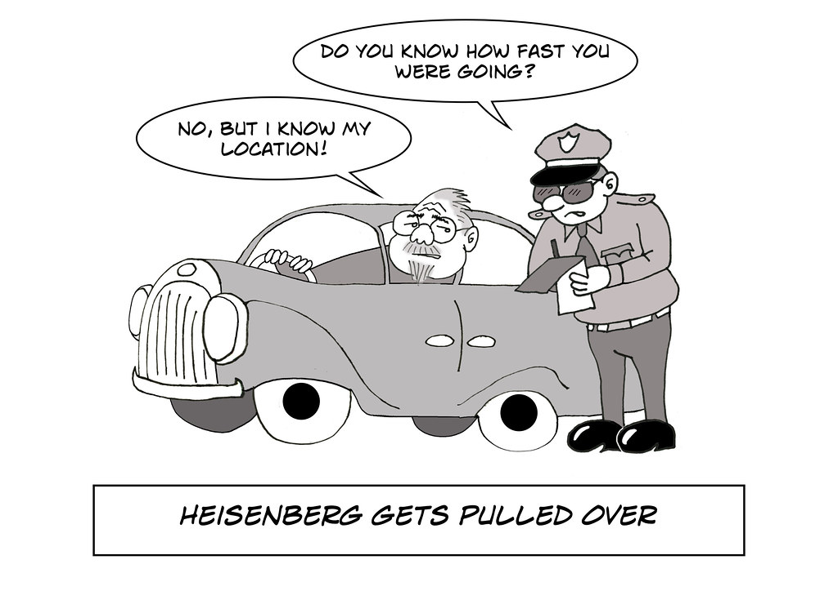

___3__2. How many sublevels are in energy level 3?

____2_3. How many sublevels are in energy level 2?

___4__4. How many sublevels are in energy level 4?

___1__5. How many orbitals are in the **s** sublevel?

____5_6. How many orbitals are in the **d** sublevel?

___7__7. How many orbitals are in the **f** sublevel?

____3_8. How many orbitals are in the **p** sublevel?

___6__9. What is the maximum number of electrons possible in the **p** sublevel?

___14__10. What is the maximum number of electrons possible in the **f** sublevel?

___10__11. What is the maximum number of electrons possible in the **d** sublevel?

___2__12. What is the maximum number of electrons possible in the **s** sublevel?

Label each orbital shape with the correct letter ( s, p, d, f )

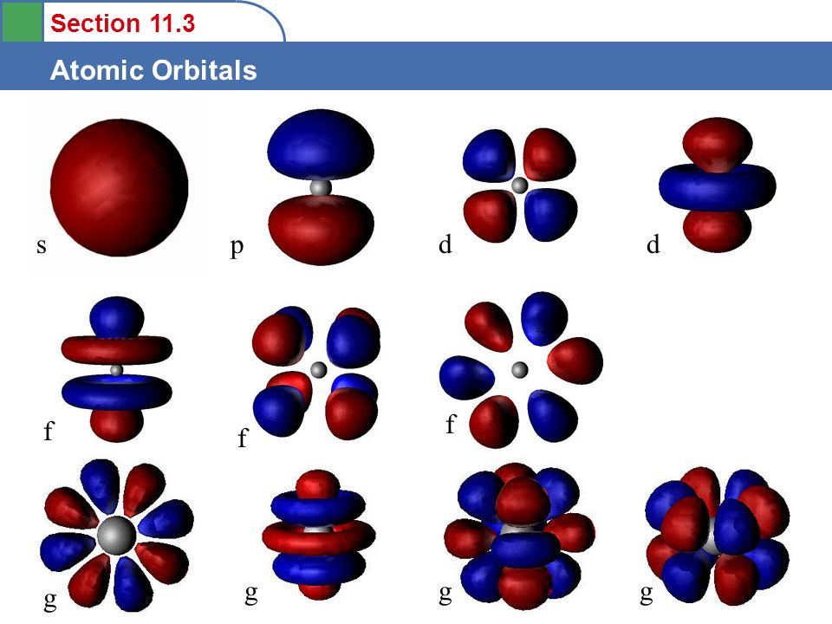

13.__p___ 14.__s___ 15.__d___ 16.__f___

17. State the Pauli Exclusion Principle as it is given in the notes:

No two electrons can have the same four quantum numbers and all quantum numbers can be the same except the spin number

18. State the Heisenberg Uncertainty Principle as it is given in the notes:

You cannot define the speed and position of an electron at the same time

